**Hoda Barakat (1952 -)**

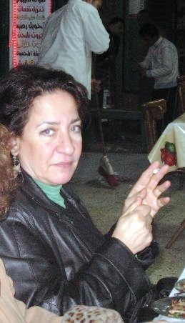SUMMARY

Hoda Barakat was born in a village in the north of Lebanon to a family of Maronite Christian faith. She studied in Beirut at the Lebanese University and then in Paris, where she went to obtain a Ph.D. However, she didn’t complete her studies there, because she decided to come back home when the Lebanese civil war broke out. In 1989 she moved once again to Paris where she currently lives.

Her first novel [*Ḥağar aḍ-ḍaḥk*](http://en.wikipedia.org/wiki/The_Stone_of_Laughter)(*The Stone of Laughter*), won the Al-Naqid prize. Her third novel, *Ḥāriṯ al-miyāh* (*The Tiller of Waters*), won the 2001 [Naguib Mahfouz Medal for Literature](http://en.wikipedia.org/wiki/Naguib_Mahfouz_Medal_for_Literature). In France she became *Chevalier de l'Ordre des Arts et des Lettres* in 2002 and *Chevalier de l'Ordre du Mérite National* in 2008. In 2013 she was the first Arab scholar in residence at the University of Texas Austin.

Hoda Barakat in Cairo in 2008

©Jolanda Guardi

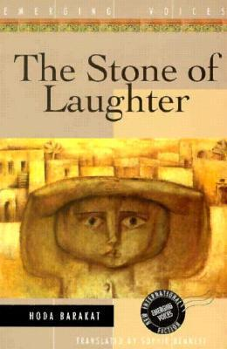MAIN ENTRY

*The Stone of Laughter* (1995) is set during the Lebanese civil war (1975-1990). The novel is often referred to as the first Arabic novel whose protagonist is a homosexual. Although this is not correct, it is true that in *The Stone of Laughter* gender plays a key role as the various characters presented use it to face the violence of war.

In Lebanese society gender is strictly assigned; opposing this, Barakat proposes androgyny as a condition where sex characteristics and human impulses expressed by masculine and feminine are not strictly assigned. In this case homosexuality means refusing a fixed identity in a context where this is based upon a strong sexual and religious mark. At the beginning of the novel, the hero tries to define his/her identity in alternative terms, living on the fringes of the war. As a counterpart, the author’s voice is marginal, although often interwoven with the character’s (the character is ‘male’ by birth). This voice will reveal itself as feminine only at the very end of the novel. The narrator too is androgynous throughout the novel, at least until circumstances change and s/he changes too. Ḫalīl, the protagonist, in fact, decides in the end to define himself as a male and the author/narrator will be forced to declare herself as a woman.

*The Stone of Laughter* cover.

Source: http://www.goodreads.com/book/show/155540.The_Stone_of_Laughter

*The Tiller of Waters* (200) is once more set in Beirut during the civil war. The protagonist, Niqula Mitri, uselessly recalls his past before the war devastated the town and his life. The novel gives Barakat the opportunity to describe the traditional arts and crafts of Lebanon as well as the different cultures that inhabited the region: Kurds, Armenians, Arabs.

Her latest novel, *Kingdom of this Earth* (2012), narrates the story of three generations of the people of Bsharri, a Maronite community in Mount Lebanon, from the beginning of the twentieth century until the eve of the Lebanese Civil War. In this novel, Barakat uses both the Arabic language and the Lebanese dialect of Mount Lebanon. Although the plot develops before the Lebanese civil war, Barakat maintains the same focus as in her other novels, i. e., her critique of the sectarian milieu in her country and the inability of Arab countries in general to achieve a real independence after colonialism. As she states in an interview, “Kingdom of this Earth is the story of the Maronite community and I think this is the first time it is represented in a novel but at the same time it is the story of a country, Lebanon, and of the failure of a ‘lebanese’ citizenship” (Inteview in French at: <https://www.youtube.com/watch?v=-bZA4L0OUtI>)



The novel has not yet been published in English, but it is possible to read an excerpt at:

<http://www.jadaliyya.com/pages/index/6057/hoda-barakat_kingdom-of-this-earth>

A roundtable discussion with Hoda Barakat at the University of Virginia:  
<https://www.youtube.com/watch?v=c8_tKBd7ukM>

**List of works**

Short stories

***زائرات***

*Za’irāt* (*Women Visitors*, 1985).

Novels

***حجر الضحك***

[*Ḥağar aḍ-ḍaḥk*](http://en.wikipedia.org/wiki/The_Stone_of_Laughter)(*The Stone of Laughter*) (1990).

***حارث المياه***

*Ḥāriṯ al-miyāh* (*The Tiller of Waters*) (2000).

***أهل الهوى***

*Ahl al-hawà* (*Disciples of Passion*) (2002)

***سيدي وحبيبي***

*Sayyidī wa-ḥabībī* (*My Lord and my Love*) (2004)

***ملكوت هذه الأرض***

*Malakūt aḏihi al-arḍ* (*Kingdom of this earth*) (2012)

English translations

[*The Stone of Laughter*](http://en.wikipedia.org/wiki/The_Stone_of_Laughter) (1995) New York: Interlink Books.

[*The Tiller of Waters*](http://en.wikipedia.org/w/index.php?title=The_Tiller_of_Waters&action=edit&redlink=1) (2001) Cairo: American University in Cairo Press.

[*Disciples of Passion*](http://en.wikipedia.org/w/index.php?title=Disciples_of_Passion&action=edit&redlink=1) (2005) Syracuse: Syracuse University Press.

*Hoda Barakat's Sayyidi wa habibi: the authorized abridged edition for students of Arabic* (2013) Washington DC: Georgetown University Press.

**Further readings**

Agachi, S. (1998) ‘Hoda Barakat’s The Stone of Laughter: Androgyny or Polarization?’, *Journal of Arabic Literature* XXIX: 185-201.

Agachi, S. (2006) ‘Contemporary Lebanese Fiction: Modernization without Modernity’, *International Journal of Middle East Studies* 38: 561-580.

Cooke, Miriam (1996) *Women and the War Story*, Berkeley, Los Angeles, London: University of California Press, 273-280.

Fayad, M. (2002) ‘Strategic Androgyny. Passing as Masculine in Barakat’s Stone of Laughter. In L. Suhair Majaj, P. W. Sunderman and T. Saliba. Eds. *Intersections. Gender, Nation, and Community in Arab Women’s Novels*, Syracuse New York: Syracuse University Press, 162-179.

Takieddine Amyuni, M. (1999) ‘Literature and War, Beirut 1993-1995: Three Case Studies’, *World Literature Today*,73 (1): 37-42.